Bar Chart

Definition
# Source: AI Source: Provided by: [Data Path: Persons Table -> ID Column: 1, Name_En Column: Motasem Essam] -> From: [Chatgpt (GPT‑5 Mini)] on [12/10/2025]
A Bar Chart is a data visualization that represents categorical data using rectangular bars, where the length or height of each bar corresponds to the value of the category.

Key Idea
# Source: AI Source: Provided by: [Data Path: Persons Table -> ID Column: 1, Name_En Column: Motasem Essam] -> From: [Chatgpt (GPT‑5 Mini)] on [12/10/2025]
Bar charts are used to compare quantities across different categories. The taller (or longer) the bar, the larger the value it represents.

How It Works
# Source: AI Source: Provided by: [Data Path: Persons Table -> ID Column: 1, Name_En Column: Motasem Essam] -> From: [Chatgpt (GPT‑5 Mini)] on [12/10/2025]
- Categories are placed on one axis (usually the x-axis).
- Values are placed on the other axis (usually the y-axis).
- Each category is represented by a bar whose height corresponds to its value.

Example
# Source: AI Source: Provided by: [Data Path: Persons Table -> ID Column: 1, Name_En Column: Motasem Essam] -> From: [Chatgpt (GPT‑5 Mini)] on [12/10/2025]
Dataset: Sales by Product
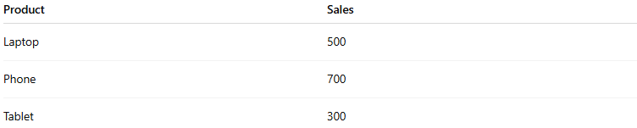
Product | Sales
Laptop | 500
Phone | 700
Tablet | 300
In a Bar Chart:
- The x-axis shows the product categories (Laptop, Phone, Tablet).
- The y-axis shows the sales values.
- Each product has a bar representing its sales amount.
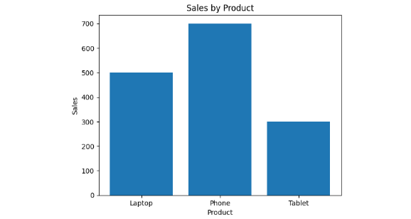

Types of Bar Charts
# Source: AI Source: Provided by: [Data Path: Persons Table -> ID Column: 1, Name_En Column: Motasem Essam] -> From: [Chatgpt (GPT‑5 Mini)] on [12/10/2025]
- Vertical Bar Chart – bars go upward.
- Horizontal Bar Chart – bars extend sideways.
- Grouped Bar Chart – compares multiple groups across categories.
- Stacked Bar Chart – shows part-to-whole relationships.

Applications
# Source: AI Source: Provided by: [Data Path: Persons Table -> ID Column: 1, Name_En Column: Motasem Essam] -> From: [Chatgpt (GPT‑5 Mini)] on [12/10/2025]
- Comparing sales across products
- Showing population by category
- Comparing survey responses
- Analyzing categorical data

Advantages
# Source: AI Source: Provided by: [Data Path: Persons Table -> ID Column: 1, Name_En Column: Motasem Essam] -> From: [Chatgpt (GPT‑5 Mini)] on [12/10/2025]
- Easy to understand and interpret
- Effective for comparing categories
- Works well with small or medium datasets

Disadvantages
# Source: AI Source: Provided by: [Data Path: Persons Table -> ID Column: 1, Name_En Column: Motasem Essam] -> From: [Chatgpt (GPT‑5 Mini)] on [12/10/2025]
- Not ideal for very large numbers of categories
- Does not show trends over time as clearly as line charts

